

Al Hussein Technical University

A Technical Analysis Report for

**MySouq  
Flask-Based Web Application for Marketplace**

Written By: Reema Eilouti  
  
GitHub: reema-eilouti

**Table of Contents**

**Introduction 3**

Thesis Statement 3

Scope 3

Methodology 3

**Database Architecture** 4

Entity Relationship Diagram 4

**Web App in Action** 5

Home Page 5

Login / SignUp 6

Profiles 7

**Conclusion** 8

Points To Be Improved 8

Summery 8

**References 9**

List of Resources 9

**Introduction**

Thesis Statement

The purpose of this project is to create an easy to use platform to buy and sell new and used items online for everyone.

Scope

This web application will be available online using the Internet. It can be accessed using any web browser. Not yet completely mobile friendly.

Methodology

For the front-end I used HTML, CSS, Bootstrap and other online resources making the user interface as simple and clear as possible.  
For the back-end I used Flask for Python, Jinja and other tools mentioned in the requirements file in order for the app to work.  
As for the database I used MongoDB.

**Database Architecture**

Entity Relationship Diagram

**Web App in Detail**

Home Page:

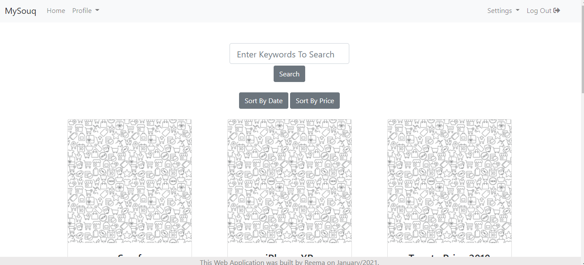

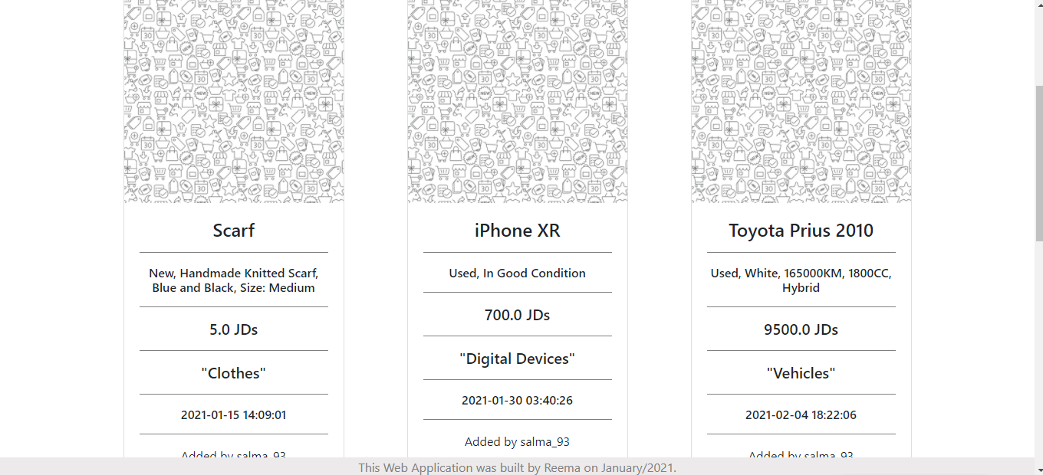

**Web App in Detail**

Login:

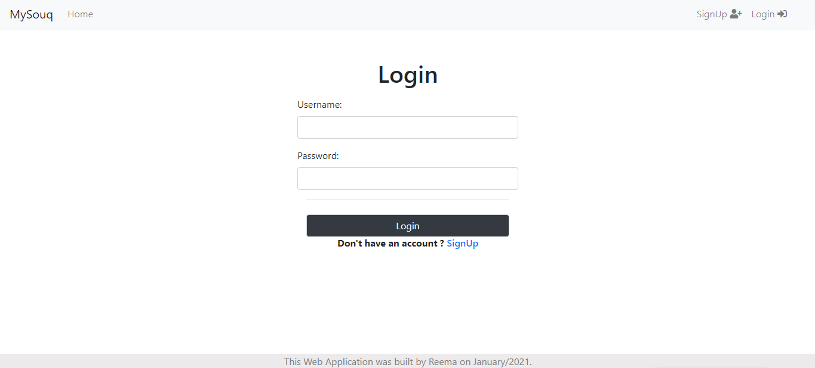

SignUp:

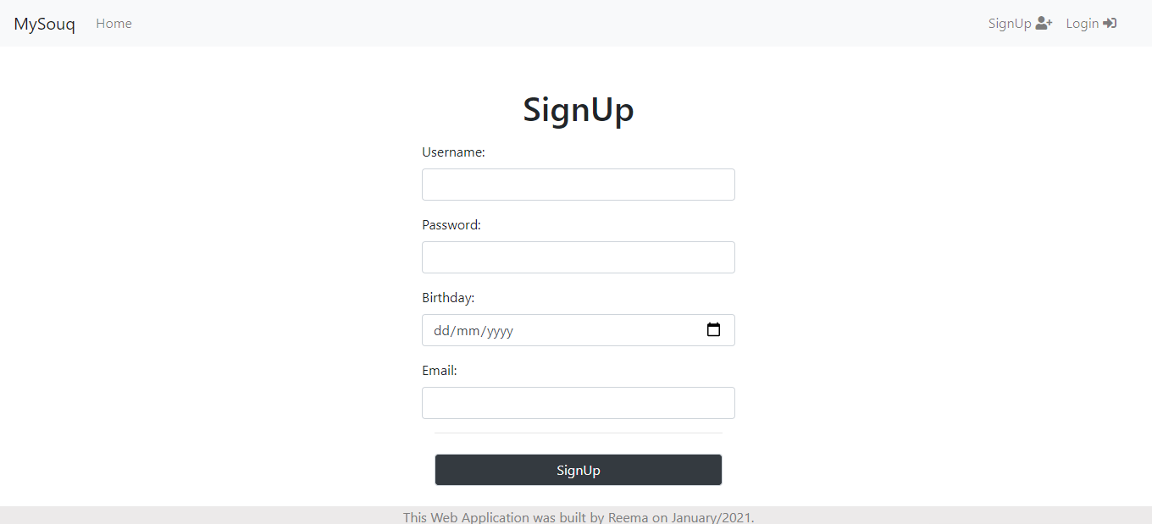

**Web App in Detail**

Buyer Profile:  
  
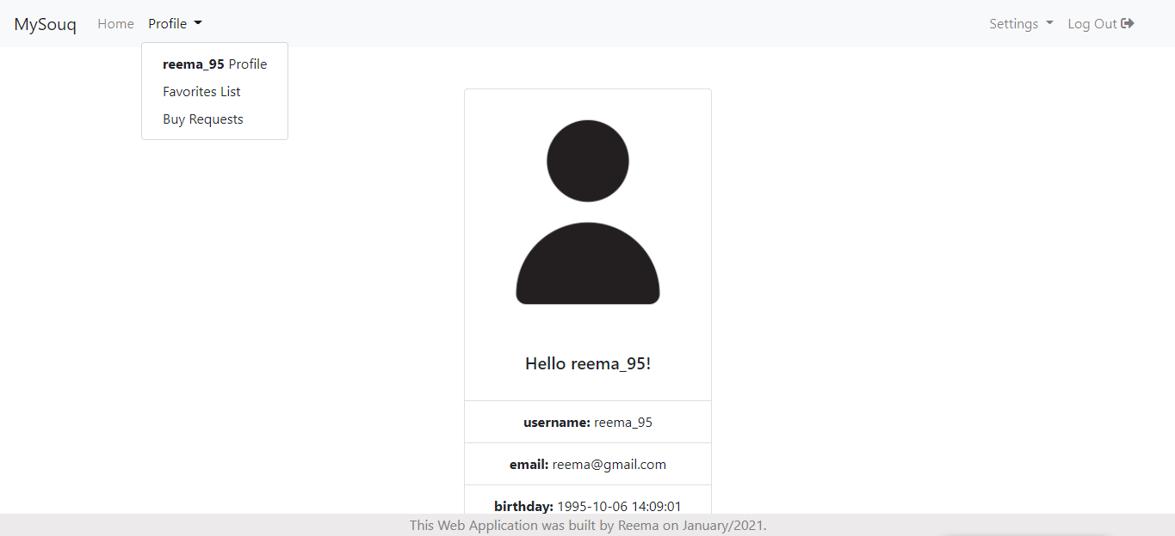

Admin Profile:  
  
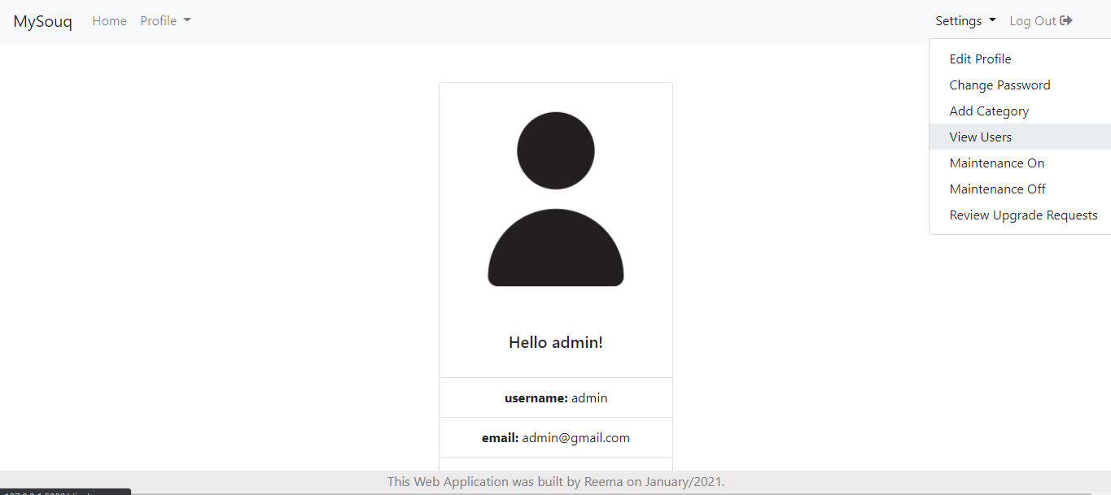

**Conclusion**

Points To Be Improved

- Mobile Friendliness.  
- Adding JavaScript for a better user experience.  
- Creating a notification page with active dynamic alerts.  
- Ability to add new images to items by Sellers.

Summery

In conclusion, MySouq is an online marketplace platform.   
Its main usage is to buy and sell items. The items can be new or sold.  
  
There are three types of users of MySouq; Buyers, Sellers and Admins.  
Each have different capabilities.  
  
The web app is accessible online using any web browser.

**References**

List of Resources

* <https://flask.palletsprojects.com/en/1.1.x/>
* <https://docs.python.org/3/>
* <https://jinja.palletsprojects.com/en/2.11.x/>
* <https://docs.mongoengine.org/guide/index.html>